Holland, Neville
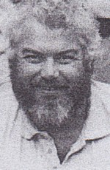
Son of Arthur (Dutchy) Holland. Went to Margaret River High School. Graduated from Forest Cadet School Dwellingup 1972. Worked in Forests Department in 1970s-1985. Locations include Nannup and Walpole. District Forester Kirup in late 1990s. Worked in Forest Production Commission, since its formation. Currently Roading Manager. Interests include fine wood, craft, golf, fishing.

